Wong, Marvin Dale S. 12/3/2019

2ECE-A 31 ECE2112

Experiment 9

DATA WRANGLING USING PANDAS

PROBLEM 1

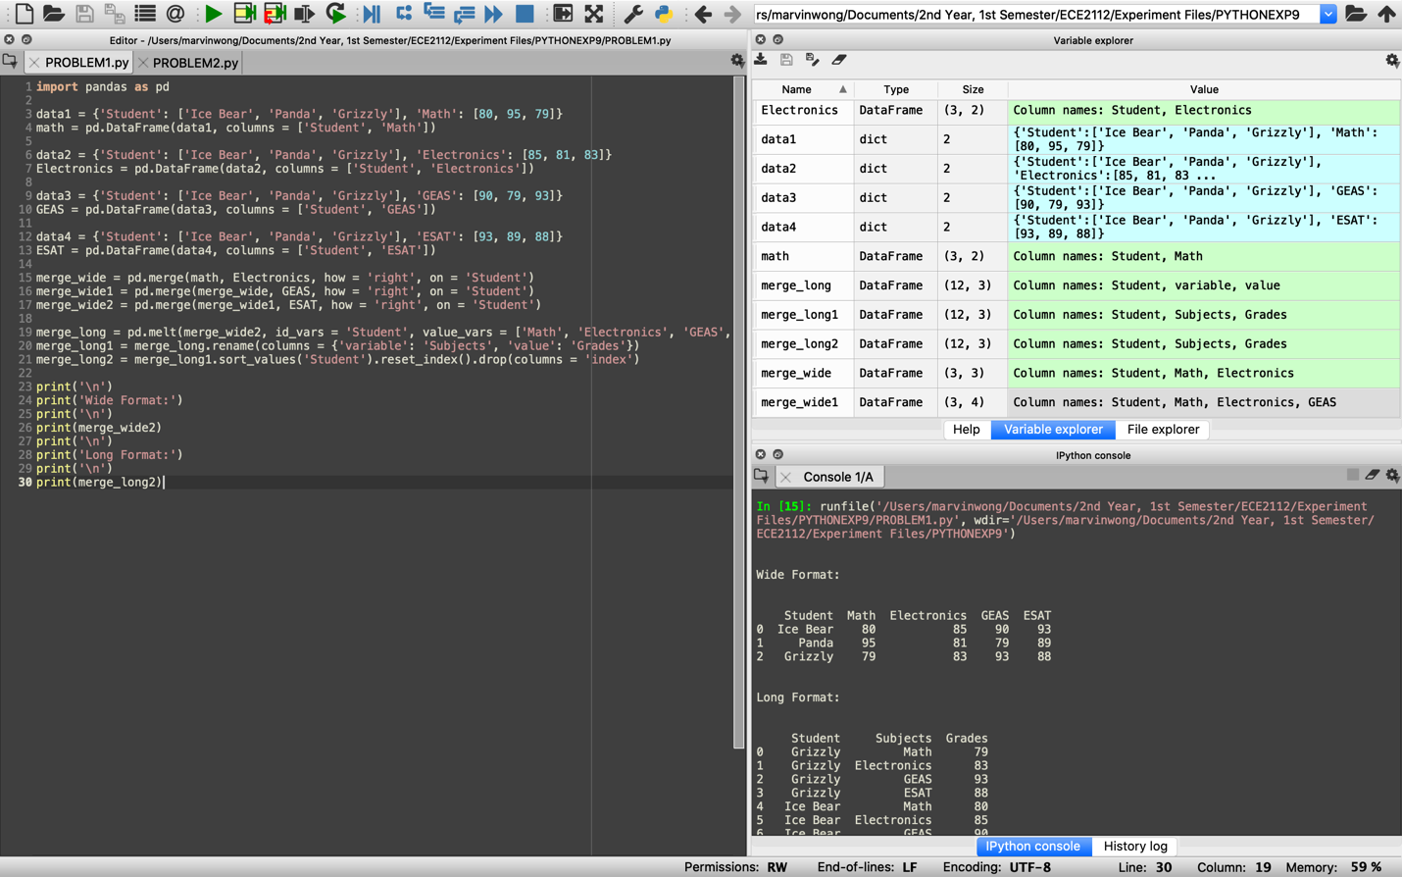

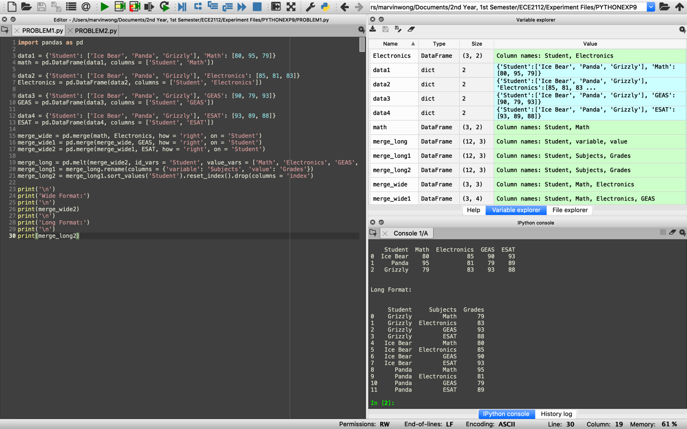

PROBLEM 2

